## Practical 1: HTML Basics

## Preparation:

1. You should have gone through the topic 1 **HTML Basics module** at [codecademy](http://www.codecademy.com/learn).
2. Review lecture slides: **Introduction to HTML**
3. While learning HTML at codeacademy, you have been using its internal editor. You will experience how to create a web page using a text editor (Atom)
4. Your learning outcomes checklist: 

* Be able to use Atom to create a simple webpage with:
* Proper HTML document structure
* Title <title>
* Headings <h1> - <h6>
* Paragraphs <p>
* Images <img>
* Text and images hyperlinks <a>
* List
* Be able to use Chrome to view webpage and inspect element.

## Part A: Try it out! (30 mins)

1. Create a **WebDev** folder in your home drive.
2. Create a sub-folder named **Practical** under **WebDev** folder

*(if you have done your tutorial, most likely you already have the folders created)*

1. Create a sub-folder name **Week1** under **Practical**.
2. Download the image file **studyRecord.png** from BlackBoard into this folder.
3. Start-up Atom.
4. Under File -> Add Project Folder, select the **Week1** folder you have created.
5. At the top menu bar, choose File -> New File.
6. Enter the following HTML code. Use the “**autocomplete-html**” package to aid you. The package is not yet installed, install it under File -> Settings -> Install.

<!doctype html>

<html lang="en">

<head>

<meta charset="UTF-8"/>

<title>MyProfile - Me </title>

</head>

<body>

<p>Hello World</p>

</body>

</html>

1. At the top menu bar, choose File -> Save As. Save the file as **exercise1.html** under the folder **Week1**

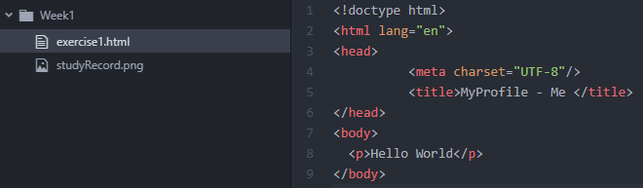

1. Check that the package “**open-in-browser**” is installed under File -> Settings -> Install. If it is not, install it.

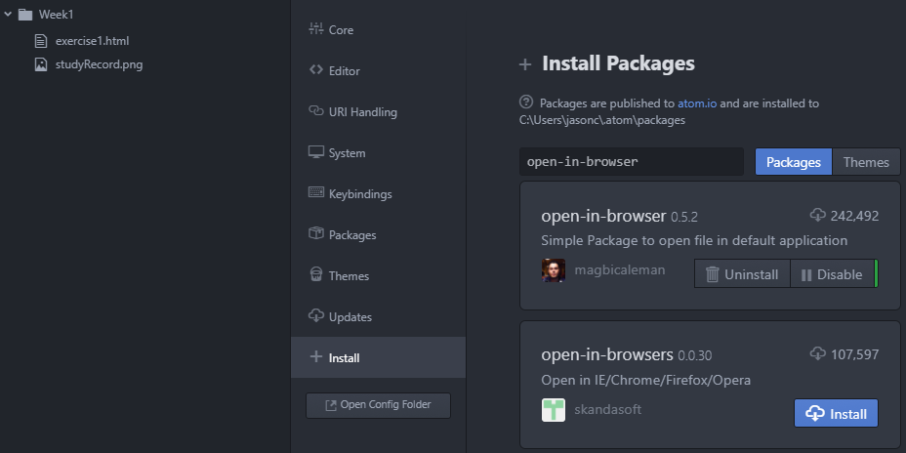

1. In the Project Pane, right-click and choose “**Open in Browser**” and launch the web page **exercise1.html** using a browser of your choice (e.g. launch in Chrome).
2. Making use of what you have learnt, create the following web page.

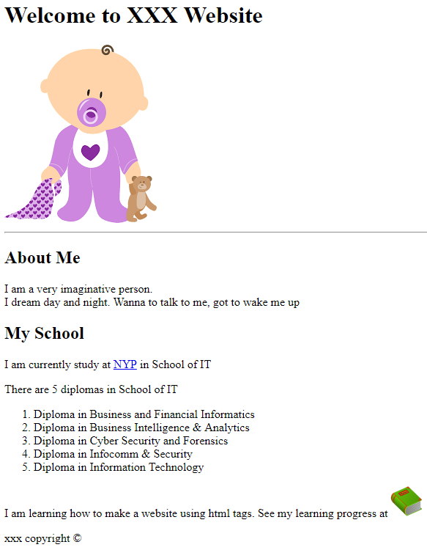

* + - *url for the image is* [*https://encrypted-tbn1.gstatic.com/images?q=tbn:ANd9GcS9DZMGYOlTA4P5mUIaV4lVxJbDEWgQgXhTeH26Wfjn9YW1wDx5cw*](https://encrypted-tbn1.gstatic.com/images?q=tbn:ANd9GcS9DZMGYOlTA4P5mUIaV4lVxJbDEWgQgXhTeH26Wfjn9YW1wDx5cw)
    - *When user click at NYP, lead the user to NYP website.*
    - *When user click at the book (studyRecord image), lead the user to codecademy.*

1. Right-click at your web page to get the following pop-up menu, select **Inspect** element:

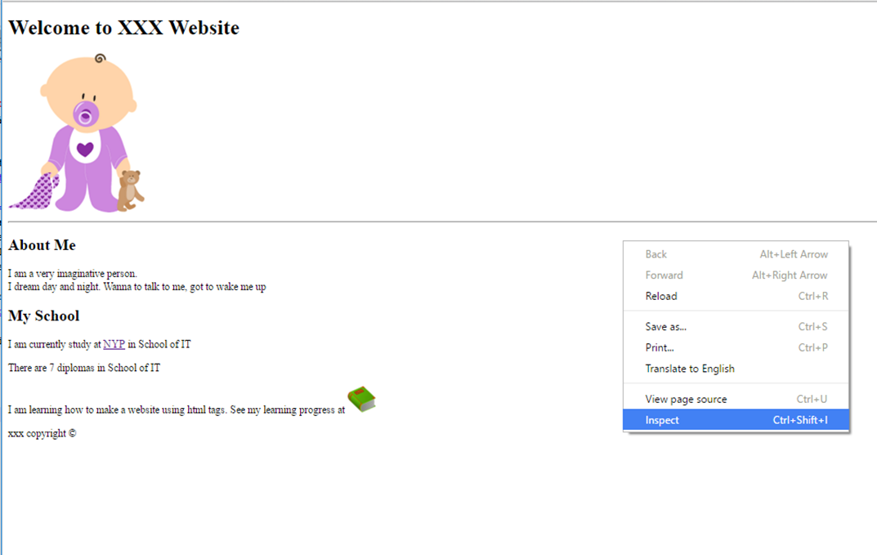

1. Modify the content of <h1>. Your modification will be immediately reflected.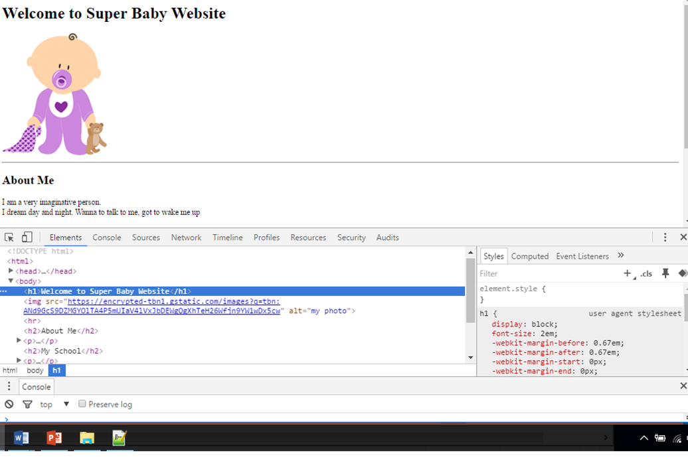

You have just experienced the usage of Chrome inspector. Your modification will not be saved into your file. Inspector will help you to debug your web page. You may use it more often when task get more complicated.

## Part B: Check and learn it together (30mins)

Show your work to your tutor. Your team may be selected to present the answer.

## Part C: Challenge Me (20mins)

1. Create a web page about yourself.
2. You web page should have

* Proper HTML document structure
* Title <title>
* Headings
* Paragraphs <p>
* Images <img>
* Text and images hyperlinks <a>
* List

## Part D: Correct Me (20mins)

1. Exchange work and mark the answers for your friends

Checked by :

1. Zip your work (Part C) and submit to BB.